Meta Title:
Contact Mukhtar Car Auctions | UAE Used Car Support Team

Meta Description:
Reach our UAE used car experts today! Get instant help finding your perfect vehicle, understanding pricing, or scheduling test drives. Call, chat, or visit our showroom.

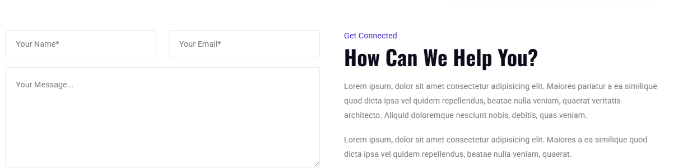

Get Connected

How Can We Help You?
Got questions about finding the right car in the UAE’s unique market? We’ve got answers. Whether you’re looking to buy used cars UAE style with confidence, need advice on the best used car to buy in UAE for your lifestyle, or want help navigating our process, our UAE-based team is ready. Call, chat, or visit our showroom for:
- Personalized vehicle matching
- Full explanation of 150-point inspection reports
- GCC specification verifications
- Transparent pricing breakdowns
- Real people. Real solutions. Zero pressure.

